RediLearning Navigation

During the RediLearning application release some devices will receive an icon with a tree in the center of it for accessing RediLearning with convenience.

For those users who do not see the icon on his/her home screen:
- Instruct user to login to RediLearning website by launching this URL:
http://lms.redilearning.com/rehabcare
- Once the user hits the home page and is prompted for RediLearning login credentials, user should hit the ‘Send To’ icon on the device and select the ‘Add to Home Screen’ option.

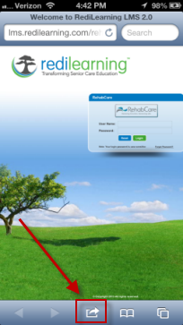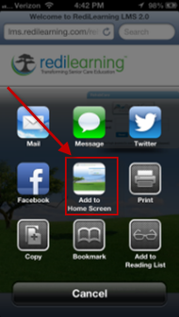

- User will then name the icon to be added. After clicking the ‘Add’ button the icon will appear on the device for convenience any time user is notified new content is available.

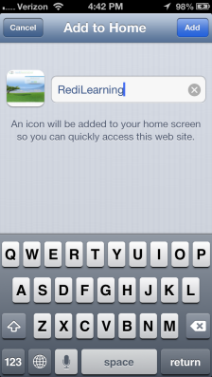

Once the application is launched the user will enter his/her Kindred username and password ‘rehabcare’.

User Name: Kindred Username
Password: rehabcare

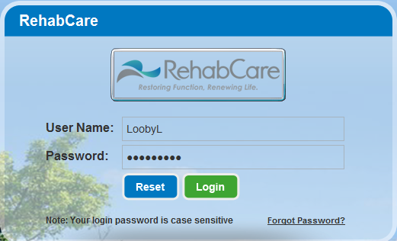

The next screen will prompt user to enter the old password of ‘rehabcare’ and to change it to a new password that has to be entered twice and that conforms to the Kindred password standard which is clearly outlined for the user in a hovering bubble.

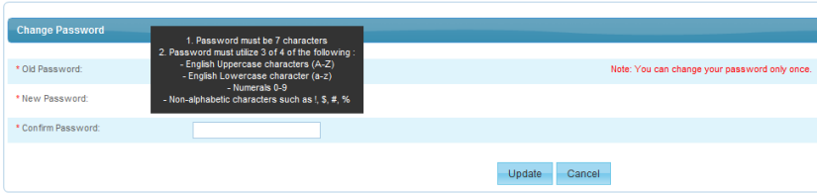

Upon entering the application users will be greeted with announcements sent to Kindred email accounts notifying him/her of new learning content available in the system. Announcements can also be made available even if not using email as the primary delivery mechanism. You may dismiss the announcement and move on to education content.

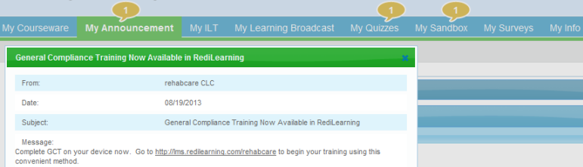

The bubbles over the various RediLearning tabs alert the user to new content. By clicking on each tab the learner can access and interact with the course content.

The ‘My Announcement’ tab contains any current and prior announcements along with the date each were posted.

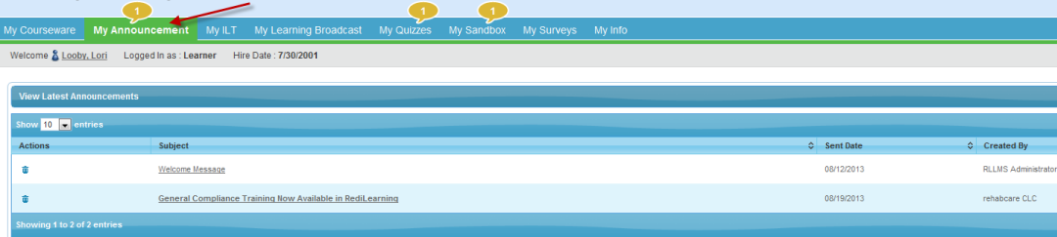

The ‘My Learning Broadcast’ tab will contain videos available for viewing. In this example the General Compliance Training (GCT) has been posted and by double clicking the clapboard the video will load and begin playing. User may view this on a computer or hand held device.

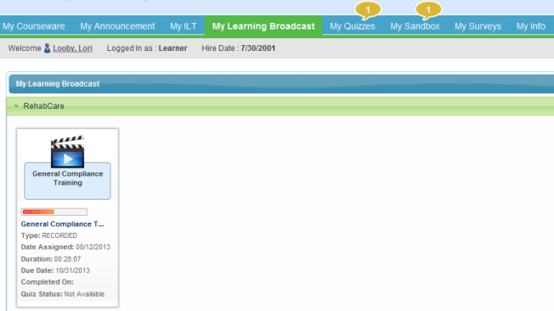

Video playing after launch:

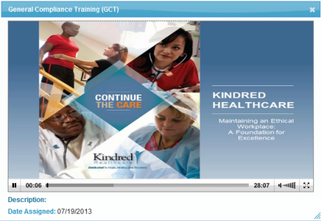

You may stop the video using the pause button in the lower left corner and even if you exit the URL completely the application will remember where you left off in viewing it to resume at a later time.
The ‘My Sandbox’ tab will contain any Microsoft (Word, Excel, Power Point) or Adobe (PDF) files available for viewing. To launch the document, click on the document icon. When user has consumed the content in the document, he/she MUST check the completion box to receive course credit if applicable. Checking this box triggers the nightly feed to LMS that will be available soon. Until RediLearning and LMS are exchanging information, rosters will continue to be faxed in to corporate. An announcement will be sent when rosters are no longer needed for employees (process will not change for contractors).
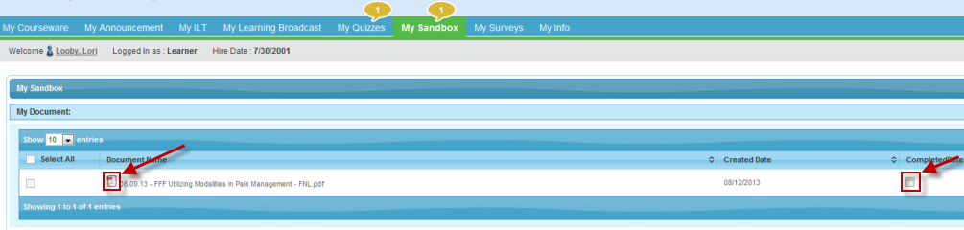

Clicking the icon will display the document the same as if emailed or accessed from computer.

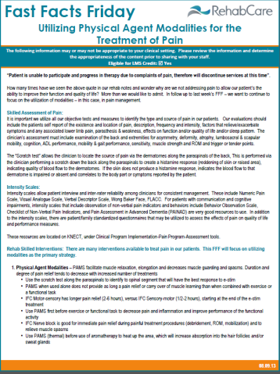

A quiz may be assigned to learning content with pass/fail requirements. When a new quiz is indicated by the bubble, launch the quiz after reviewing the content it accompanies and answer the questions to the best of your ability. If learner fails the quiz, the system will allow user to retake it if the creator set it up to allow for a minimum passing score. To launch it you would simply click on the underlined quiz name.

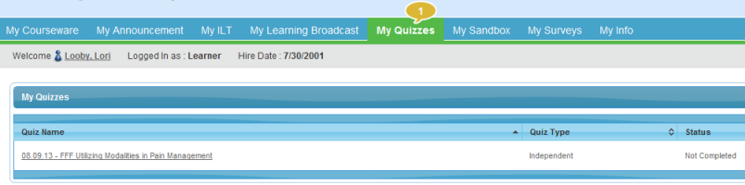

COMING SOON
Instructor Led Training (ILT)

This feature within LMS allows the instructor (PD) to grant credit to multiple participants who attend training conducted in a group setting without faxing in a paper roster. Instead the instructor will mark off attendees in RediLearning and those individuals will receive credit when RediLearning updates LMS. Instructor must keep a roster on site with signatures to meet compliance requirements.

Until the ILT module is ready, please continue conducting these sessions business as usual which includes faxing in the rosters for LMS credit. An announcement will be sent when this new component is ready.

